Functional Specification Interface
PLAN ORDER

Document Management

Versioning
.
Version | Date | Description | Revised By
1.0 | 04/28/2020 | Initial Draft

Approvals.
Version | Approval Date | Approved By | Role Function
1.0

Table of Contents

1. Interface Tracking 4
1.1 Interface Classification 4
2. Interface Functionality Requirements 5
2.1 Process Flow / Data Flow 5
2.2 Assumptions 5
2.3 Out of scope 5
3. Extract and Transfer Logic in JDA 6
3.1 Source / Target Data Mapping 6
3.1.1 Outbound file specification 6
3.1.2 Outbound file to JDA Source Data Mapping 7
3.2 Data Filters 7
3.3 Data Selection – Delta or Full Extraction 7
3.4 Extraction Logic 8
3.5 SeeBurger integration details 8
3.6 Data Retention in JDA 9
4. Inbound to SAP 10
4.1 Interface Load Logic 10
4.2 Error Handling 10
5. Error Communication 11
5.1 Error Detection and Communication 11
6. Data Retention in SAP 12
7. Open items 13

Interface Tracking

Interface Classification
W2
Interface Number | INT_020
Interface Name | PLAN ORDER
Direction (with respect to R/3) | INBOUND to SAP
Interface Type | OUTBOUND from JDA
Interface  Frequency | Weekly Details: This interface will be loaded weekly
Type of Records Sent | TXT File
Volume  (per single execution) | Average Volume:  Peak Volume:

Interface Functionality Requirements
Plan Order represents replenishments for Finised Good from Plants by manufacturing.
Plan Order for plants are generated in Blue Yonder’s Supply Plannin system as Plan Orders and this information is extracted and interfaced to TataConsumer’s SAP system for Plant Scheduling.`11

2.1 Process Flow / Data Flow
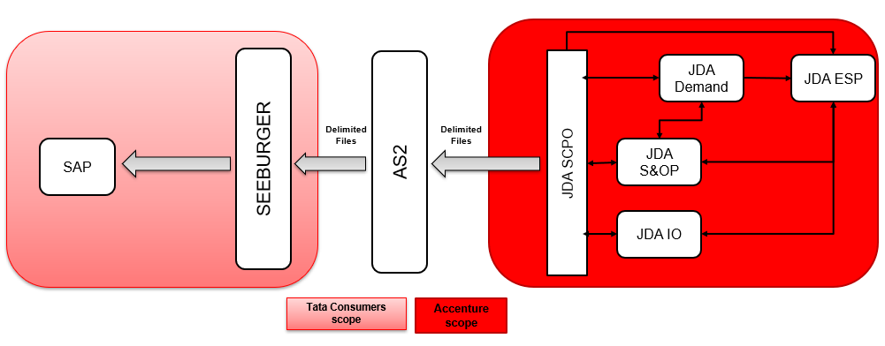

2.2 Assumptions
- Latest snapshot of Plan Orders for Finished Goods at 12 Plants will be extracted in JDA and sent to SAP Weekly.

2.3 Out of scope
- Any change in Plan Order as part of nomenclature in future to be handled separately and not considered at the time of preparing this design.

Extract and Transfer Logic in JDA
Plan Orders information which is available in JDA will be extracted and sent to SAP for Plant Scheduling.
This section provides information regarding Plan Orders extraction logic in JDA and Transfer Mechanism to TataConsumers SAP system.

3.1 Source / Target Data Mapping
This section provides information regarding the format in which Plan Order information will be made available to SAP and mapping between JDA and SAP.

3.1.1 Outbound file specification

Plan Order information from JDA will be extracted and sent as flat file to SAP.

Below are the details regarding naming and format of outbound file to SAP. Outbound file will be sent as SAP_PLANORDER_<TIMESTAMP>.txt. TIMESTAMP represent the time when the plan order information is extracted from JDA.
bnv n
Below are the details regarding the format of the file content.
SAP_PLANORDER_TIMESTAMP.txt.
- Field delimiter: “~” (tilde) character
- Text File
- There will be a header record with the following fields, separated by delimiter “~”. Data records has field information as per the header record
- JDA team to use ‘Interface Header Fields’ to create the header on the file.

3.6 Data Retention in JDA
l
Selection |  | Comments
 | None
 | 7 Days
 | 15 Days
 | 30 Days
 | Other | The outbound files which are extracted and sent to Seeburger will be archived for last 3 months, post which it will be deleted

Inbound to SAP

4.1 Data Filters

Interface Load Logic
Input Screen Selection
SL # | Field Description | Technical Details | Mandatory Field  YES/NO | Field Type
1 | Plant | MARA-WERKS | YES | Select-Option
2 | Material Type | MARA- MTART | YES | Select-Option
3 | File Path |  |  | Select-Option

Standard BAPI BAPI_PLANNEDORDER_CREATE will be used to convert the data from internal table to planned order
Field Description | Field Name | Data type & Length | JDA fiels Name | BAPI table | BAPI fields
Tracking Number |  | CHAR (10) | SEQNUM
Material | MATNR | VARCHAR (10,0) | ITEM | HEADERDATA | MATERIAL
Plant | PLWRK | VARCHAR (4,0) | LOC | HEADERDATA | PLAN_PLANT
Order Qty | GSMNG | FLOAT | QTY | HEADERDATA | TOTAL_PLORD_QTY
Order Start Date | PSTTR | DD.MM.YYY | STARTDATE | HEADERDATA | ORDER_START_DATE
Order Finish Date | PEDTR | DD.MM.YYYY | FINISHDATE | HEADERDATA | ORDER_FIN_DATE
Base Unit of Measure | MEINS | VARCHAR (10,0) | U_BASEUOM | HEADERDATA | BASE_UOM
Order Type | PAART | VARCHAR(4,0) | ORDER_TYPE | HEADERDATA | PLDORD_PROFILE
Production Version | VERID | NUM (2,0) | PRODUCTIONVERSION | HEADERDATA | VERSION
Program: Z1PP008REP_JDA (Weekly Program) and Z1PP009REP_JDA (Error Upload Program)
Logic:
Step 1 : Identify the Data whether it’s constraint demand (LA) or unconstraint demand (LB) or Both (LA and LB) by checking ORDER_TYPE
Logic for Constraint Demand (LA):
Step 2: Pass input Plants (WERKS) to PLAF Plants (PLWRK), Order Type (PAART) as LA, Order start (PSTTR) is execution date to till 4 Months
Collect all Planned Orders (PLNUM)
Step 3: Collect all Planned Orders (PLNUM) from PLAF and pass it to BAPI_PLANNEDORDER_DELETE to delete.
Step 4: Compare the demand which we received from JDA with input plants (WERKS) and if any wrong plants in input file then display those records under error section.
and next pass materials from upload file to table MARA Material (MATNR) with input Material Type (MTART) and Deletion Flag (LVORM)is equal to space and if any wrong materials in input file then display those records under error section.
And upload remaining data using BAPI BAPI_PLANNEDORDER_CREATE and display errors if any.
And for constraint demand remove the firming indicator through BAPI.
Upload file will be for constraint as below:

Logic for Unconstraint Demand (LB):
Step 2: Pass input Plants (WERKS) to PLAF Plants (PLWRK), Order Type (PAART) as LA, Order start (PSTTR) is from 13th Month to till 24th month
Ex: if execution date is 01.09.2020 then Order start date should be considered as 01.09.2021 to 31.08.2022
If if execution date is 20.09.2020 then Order start date should be considered as also 01.09.2021 to 31.08.2022
Collect all Planned Orders (PLNUM)
Step 3: Collect all Planned Orders (PLNUM) from PLAF and pass it to BAPI_PLANNEDORDER_DELETE to delete.
Step 4: Compare the demand which we received from JDA with input plants (WERKS) and if any wrong plants in input file then display those records under error section.
and next pass materials from upload file to table MARA Material (MATNR) with input Material Type (MTART) and Deletion Flag (LVORM) is equal to space and if any wrong materials in input file then display those records under error section.
And upload remaining data using BAPI BAPI_PLANNEDORDER_CREATE and if any wrong plants in input file then display those records under error section.
And if any demand is having dates before of 13th Months then display those records under error section.
And for unconstraint demand remove the firming indicator through BAPI.
Upload file will be for unconstraint as below:
Logic for Constraint (LA) and Unconstraint (LB) Demand:- This was going to be used majorly. JDA is confirmed every week they will sending full load of constraint and unconstraint.
Step 2: Pass input Plants (WERKS) to PLAF Plants (PLWRK), Order Type (PAART) as LA, Order start (PSTTR) till 24th month
L1: 1st to 7th
L2: 8th to 14th
L3: 15th to 21st
L4: 22nd to 30th or 31st (Depends Month End Date)

Ex: if execution date is 1 to 7th Sep 2020 then Order start date should be considered as L2 to 31.08.2022, (L1 is Freezed)
If if execution date is 15th to 21st Sep 2020 then Order start date should be considered as L4 to 31.08.2022 (L3 is Freezed)
Collect all Planned Orders (PLNUM)

Step 3: Collect all Planned Orders (PLNUM) from PLAF and pass it to BAPI_PLANNEDORDER_DELETE to delete.
Step 4: Compare the demand which we received from JDA with input plants (WERKS) and if any wrong plants in input file then display those records under error section.
and next pass materials from upload file to table MARA Material (MATNR) with input Material Type (MTART) and Deletion Flag (LVORM) is equal to space and if any wrong materials in input file then display those records under error section.
And upload remaining data using BAPI BAPI_PLANNEDORDER_CREATE and if any wrong plants in input file then display those records under error section.
And if any demand is having dates before of 13th Month for LB then display those records under error section.
Upload file will be for constraint and unconstraint as below:
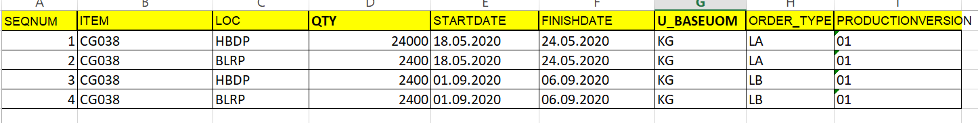

Error Handling

Interface Name | Interface Fields | Validations | Error Message in File
PLANORDER TO SAP | PLWRK | Error | Plant does not exist
PLANORDER TO SAP | MATNR | Error | Invalid Material no
PLANORDER TO SAP | GSMNG | Error | Quantity can not be a characters
PLANORDER TO SAP | PSTTR | Error | Order start date is not valid
PLANORDER TO SAP | PEDTR | Error | Order finish date is not valid
PLANORDER TO SAP | MATNR | Error | Material is Marked for Deletion
PLANORDER TO SAP | MATNR | Error | Material no is mandatory
PLANORDER TO SAP | GSMNG | Error | Order quantity is mandatory
PLANORDER TO SAP | PLWRK | Error | Plant is mandatory
PLANORDER TO SAP | PSTTR | Error | Order Start date is Mandatory
PLANORDER TO SAP | PEDTR | Error | Order Finish date is Mandatory
PLANORDER TO SAP | PLWRK | Error | Plant is not as per input plant
PLANORDER TO SAP | MATNR | Error | Material Type is not matching with input

If Any errors in uploaded file then those data to be reuploaded through another program where it will create Planned Orders for requirements and this program will not delete any planned orders.

Error Communication

Error Detection and Communication
Notification Mechanism
Urgency | Critical
Impact to the business in the event of this error | This is a critical interface for planning purposes. Non availability of this data would be a critical impact to the planning.

Data Retention in SAP

Selection |  | Comments
 | None
 | 7 Days
 | 15 Days
 | 30 Days
 | Other

Open items

SNO | DATE | OPEN POINT | Pending with | STATUS
` |  | Delimiter of the file is ~ - Align with Seeburger team | SeeBurger

